## Cloudize the WebSphere Portal Runtimes

### Setup Nexus

Refer to <http://www.sonatype.org/nexus/>

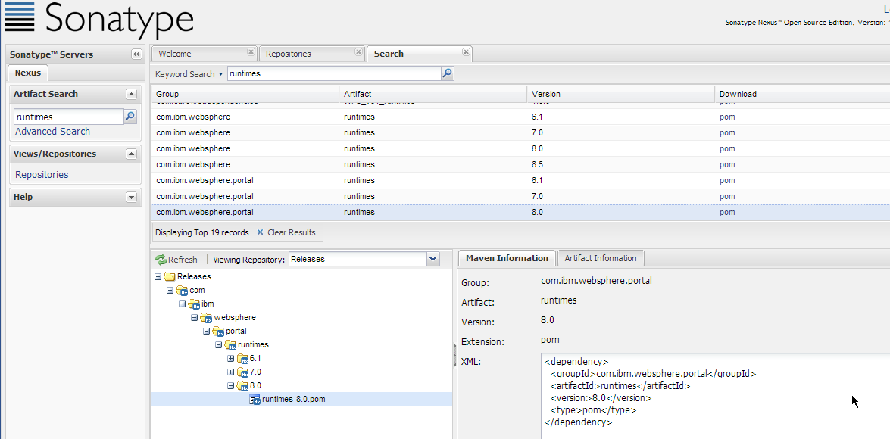

### Install and configure Maven

[http://maven.apache.org](http://maven.apache.org/)

Configure the settings.xml from maven/config/settings.xml or {userhome}/.m2/settings.xml

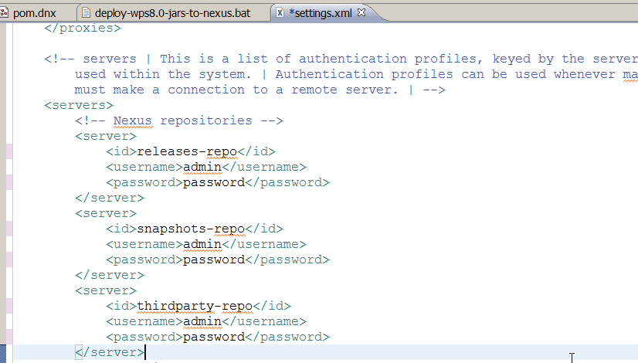

### Deploy local WebSphere Portal Jars

Maven command snippet for deploying WPS Jars to Nexus

*mvn deploy:deploy-file -Durl=http://nexus-box1:8081/nexus/content/repositories/thirdparty/ -DrepositoryId=thirdparty-repo -DgroupId=com.ibm.websphere.portal -Dversion=8.0 -Dpackaging=jar -DartifactId=wp.base -Dfile="C:\Program Files (x86)\IBM\SDP85\runtimes\portal_v80_stub\base\wp.base\shared\app\wp.base.jar"*

*mvn deploy:deploy-file -Durl=http://nexus-box1:8081/nexus/content/repositories/thirdparty/ -DrepositoryId=thirdparty-repo -DgroupId=com.ibm.websphere.portal -Dversion=8.0 -Dpackaging=jar -DartifactId=wp.cmd.base -Dfile="C:\Program Files (x86)\IBM\SDP85\runtimes\portal_v80_stub\base\wp.cmd.base\shared\app\wp.cmd.base.jar"*

*mvn deploy:deploy-file -Durl=http://nexus-box1:8081/nexus/content/repositories/thirdparty/ -DrepositoryId=thirdparty-repo -DgroupId=com.ibm.websphere.portal -Dversion=8.0 -Dpackaging=jar -DartifactId=wp.db.api -Dfile="C:\Program Files (x86)\IBM\SDP85\runtimes\portal_v80_stub\base\wp.db.api\shared\app\wp.db.api.jar"*

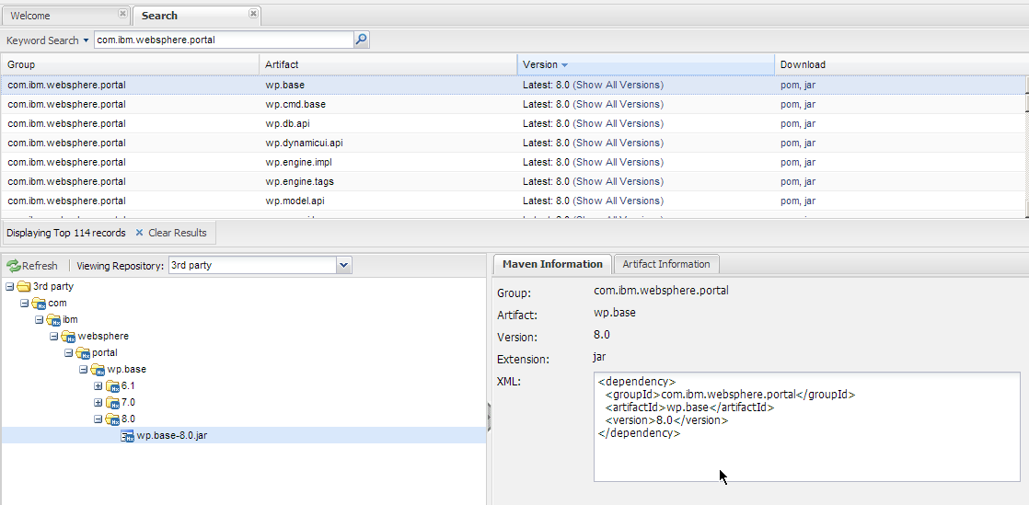

### Create WebSphere Portal runtime POM

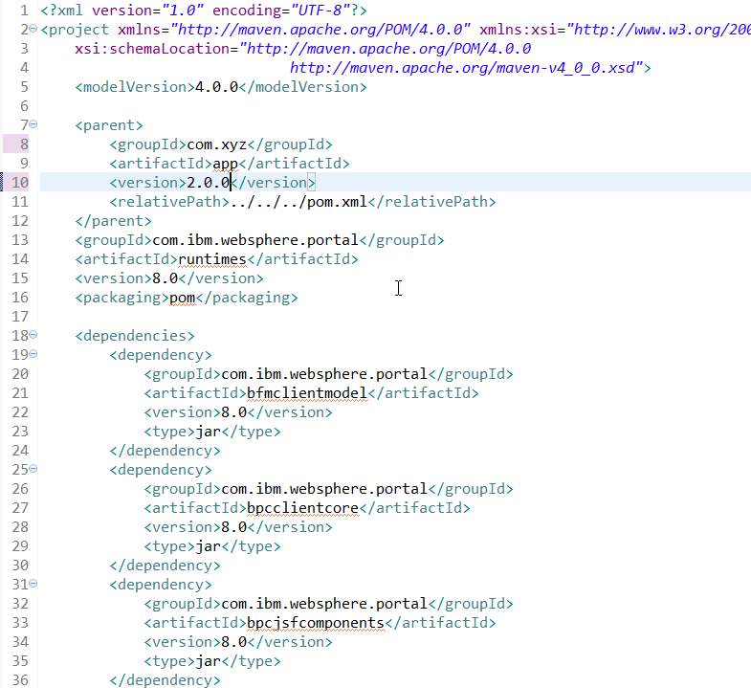

WebSphere Portal Runtimes POM:

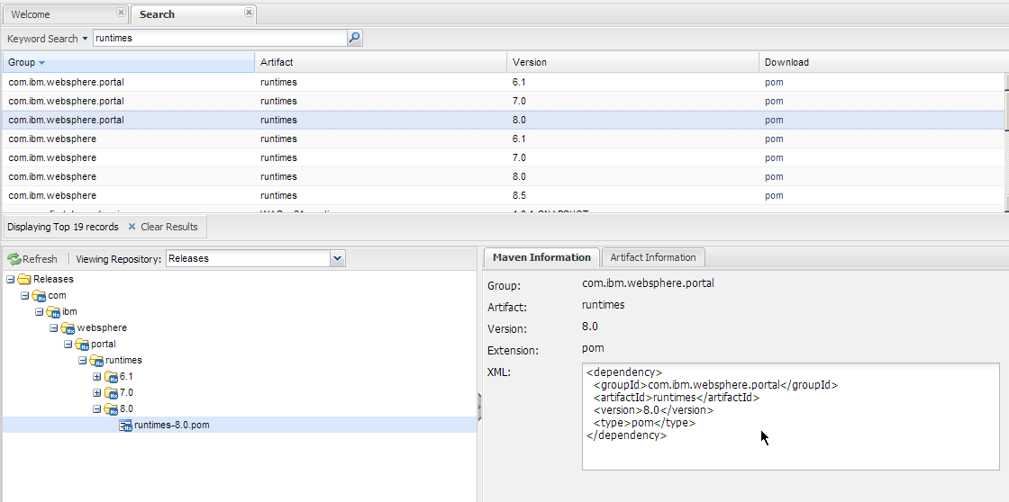

### Compile with WPS runtime POM

Add Local nexus repository to project POM file, and com.ibm.websphere.portal.runtimes:RELEASE for dependency.

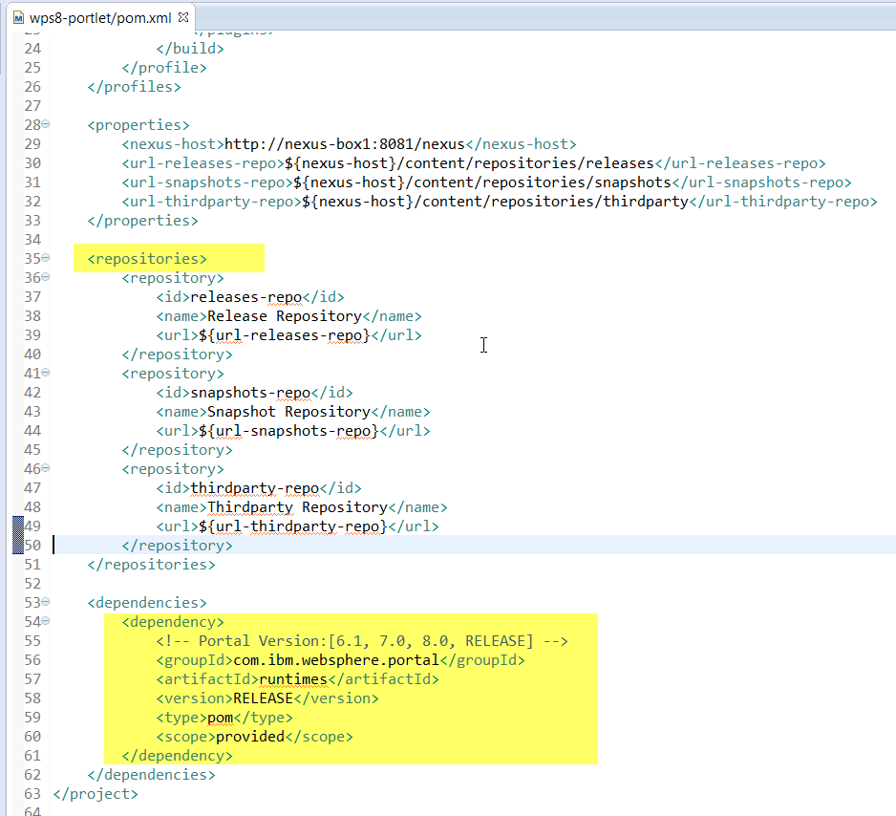

## Create Portlet Archetypes

### Create a template portlet project

mvn clean archetype:create-from-project -f wps8-portlet/pom.xml

### Create Archetype and publish it on Nexus

mvn clean deploy -f wps8-portlet/target/generated-sources/archetype/pom.xml

### Install the m2e plugin

Refer to <https://www.eclipse.org/m2e/>

### Integrate the eclipse with local archetype-catalog.xml

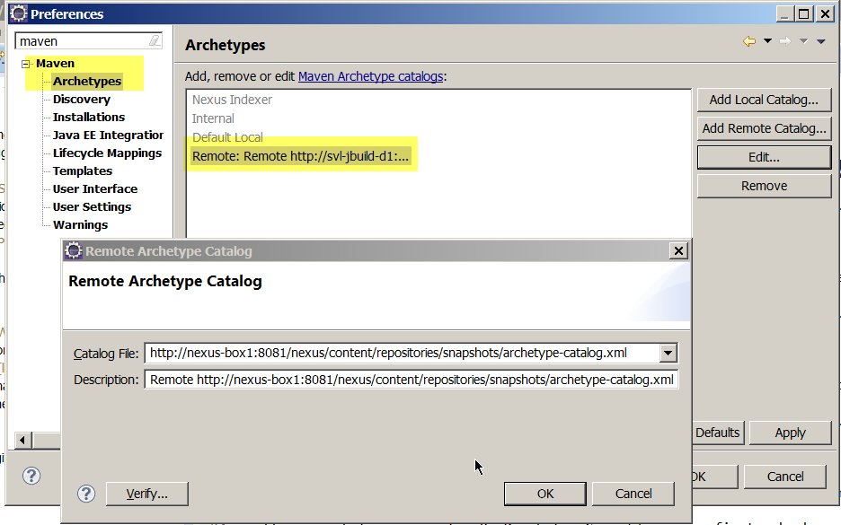

Create Portlet with eclipse maven wizard

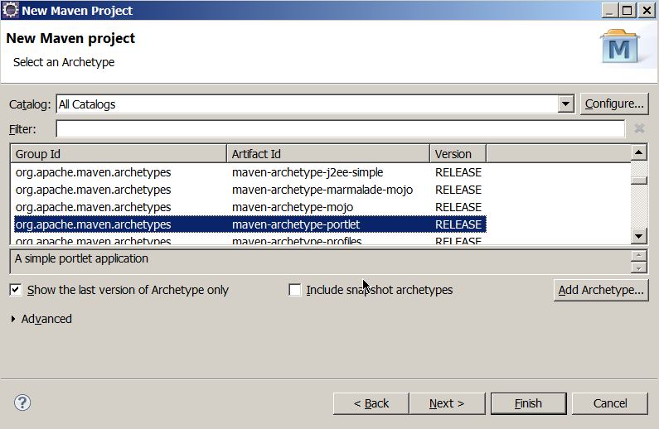

## Get started with websphere-portal-plugin

### Configure websphere-portal-plugin

Configure in your POM

<pluginRepositories>

<pluginRepository>

<id>jxquery-repo</id>

<name>jxquery Maven Repository</name>

<url>http://jxquery.googlecode.com/svn/repo</url>

</pluginRepository>

</pluginRepositories>

<build>

<pluginManagement>

<plugins>

<plugin>

<groupId>websphere.portal.plugin</groupId>

<artifactId>websphere-portal-plugin</artifactId>

<version>1.0.0</version>

</plugin>

</plugins>

</pluginManagement>

</build>

Configure Settings.xml  
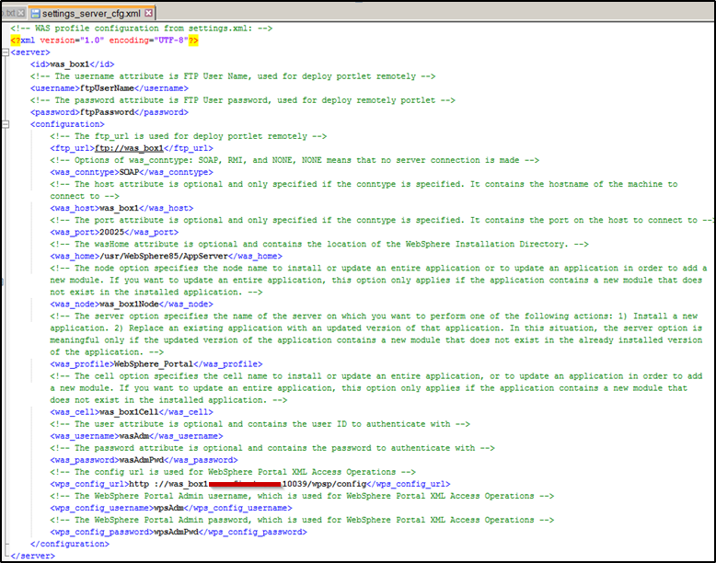

### Example of usage

1. Build and deploy a portlet   
*mvn clean package websphere:deploy-portlet -Dserver=was_box1*   
2. Deploy an existing portlet:   
*mvn clean websphere:deploy-portlet -Dserver=was_box1 -DinstallableApp=C:/dist/portlet1.war*   
3. Deploy portlet with customer uniqueNames   
*mvn clean websphere:deploy-portlet -Dserver=was_box1 -DinstallableApp=C:/dist/portlet1.war -DuniqueNames=com.xyz.plt1*   
4. Deploy portlet from Nexus   
*mvn clean websphere:deploy-portlet -Dserver=was_box1 -DinstallableApp =http://stype-nexus:8081/nexus/content/repositories/releases /com/xyz/ptl1/9.34.87/ptl1-9.34.87.war*

### Reference

https://github.com/JuanyongZhang/websphere-portal-plugin/

## Agilize the Portal Development

### Integrate with Hudson/Jenkins